**Wire-Frame Design**

**Travel Package PREDICTION**

|  |  |
| --- | --- |
| Written By | Aadil Hussain Teeli |
| Document Version | 1.0 |
| Last Revised Date | 20-02-2024 |

**Document Change Control Record**

|  |  |  |  |
| --- | --- | --- | --- |
| **Version** | **Date** | **Author** | **Comments** |
|  |  |  |  |
|  |  |  |  |
|  |  |  |  |
|  |  |  |  |
|  |  |  |  |
|  |  |  |  |
|  |  |  |  |
|  |  |  |  |
|  |  |  |  |
|  |  |  |  |
|  |  |  |  |
|  |  |  |  |
|  |  |  |  |
|  |  |  |  |
|  |  |  |  |
|  |  |  |  |

**Reviews**

|  |  |  |  |
| --- | --- | --- | --- |
| **Version** | **Date** | **Reviewer** | **Comments** |
|  |  |  |  |

### **Approval Status:**

|  |  |  |  |  |
| --- | --- | --- | --- | --- |
| **Version** | **Review date** | **Reviewed By** | **Approved By** | **Comments** |
|  |  |  |  |  |

**Homepage**

The homepage will provide information about the model name and emphasize key aspects of the project.

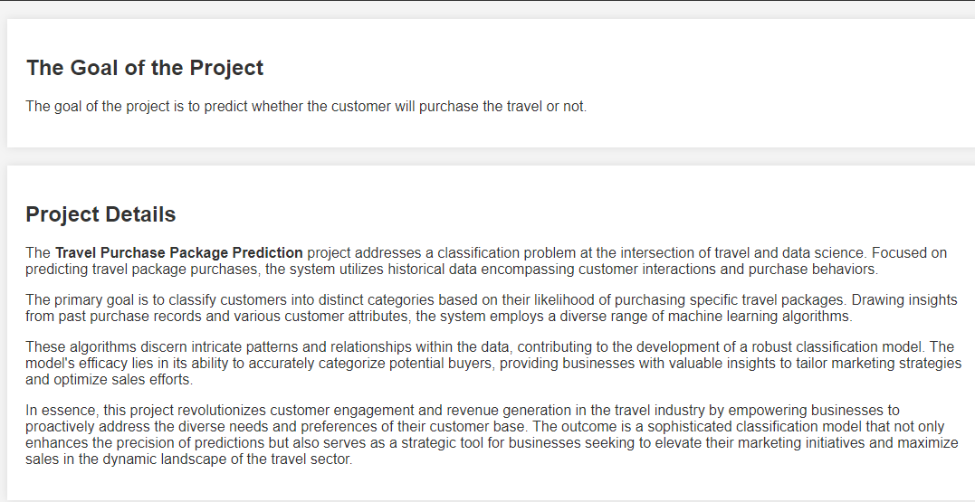

**Prediction Page**

In this project, you are required to provide 18 essential input values related to customer details. Once you successfully input the required information, you can submit the details by clicking the submit button. Subsequently, the model will predict whether the customer is likely to purchase the package or not.

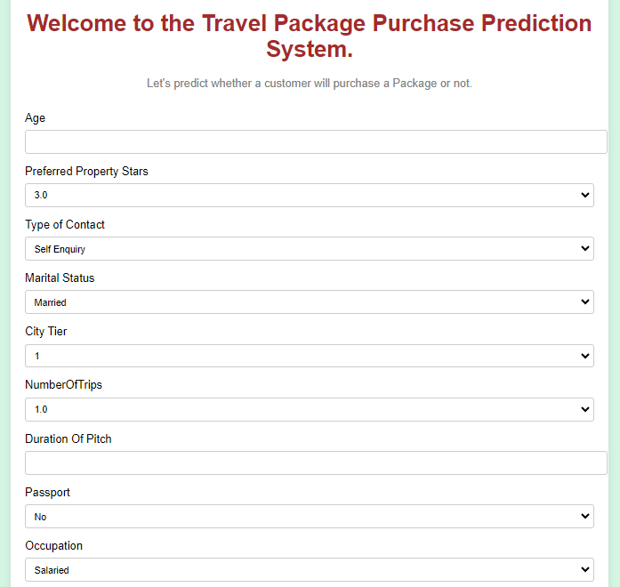

R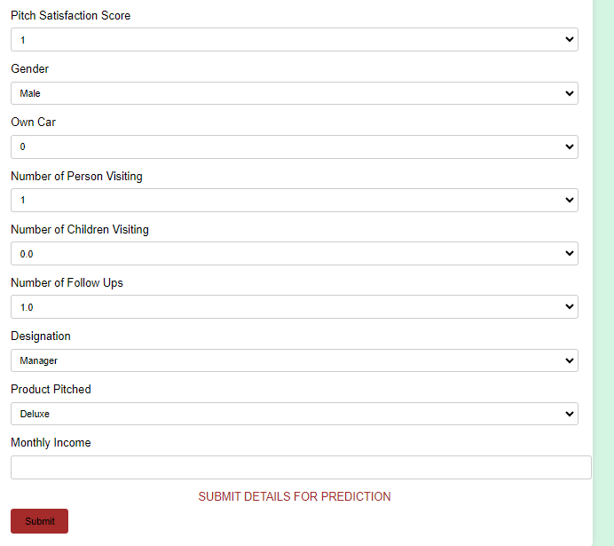

**Result Page**

After clicking the submit button you will get the result like whether the customer will purchase the package or not.

